1. INTRODUCTION
   1. Overview

The “irevolution: Exploring the impact iphone in india” is a fascinating influence of Apples iconic iphone in the context of the indian market. This revolutionary device, know for its innovative technology and sleek design, has not only changed the way we communicate and access information globally but has also had a profound effect on various facets of indian society and economy. In this exploration, we will delve into the evolution of the iphone in india, its socio-economic implications, and how it has shaped the digital landscape, and how it has shaped the digital landscape of the country.

* 1. Purpose

1.Socio-economic transformation

2.Digital inclusion

3.E-commerce growth

4.Education and skill development

5.Entertainment industry

6.Healthcare and fitness

7.Government initiatives

1. PROBLEM DEFINITION & DESIGN THINKING
   1. Empathy map

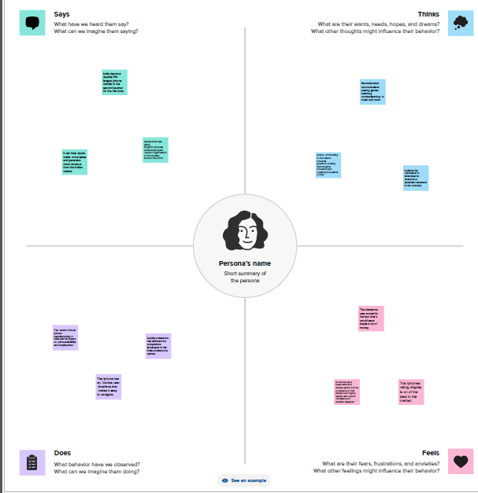

* 1. Ideation & Brainstorming map

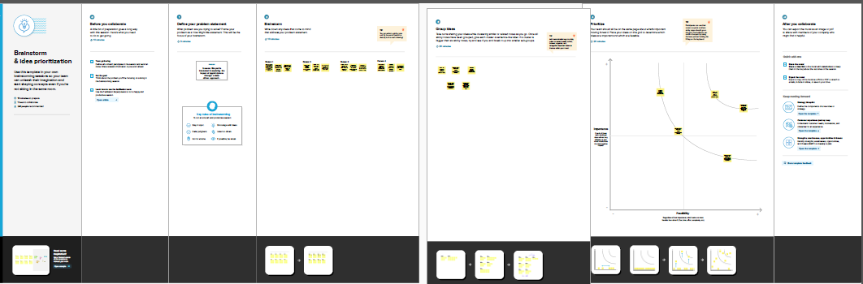

1. RESULT

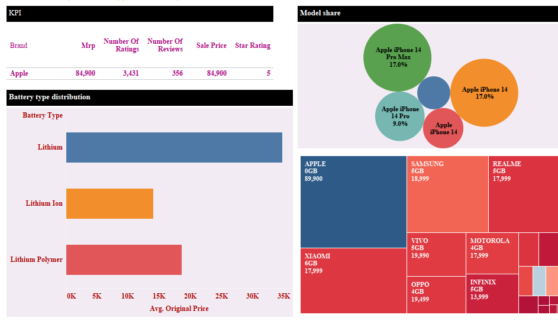

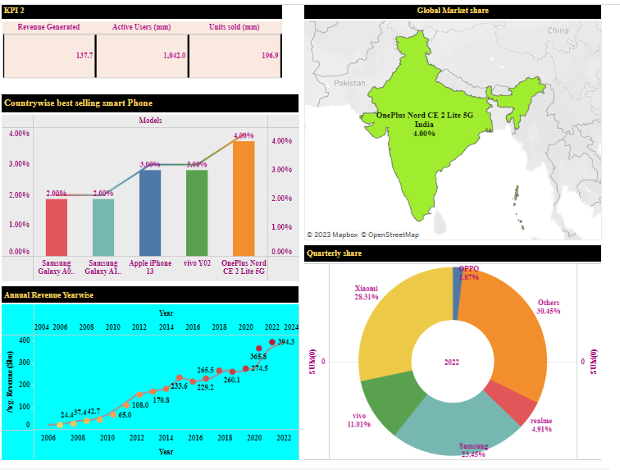

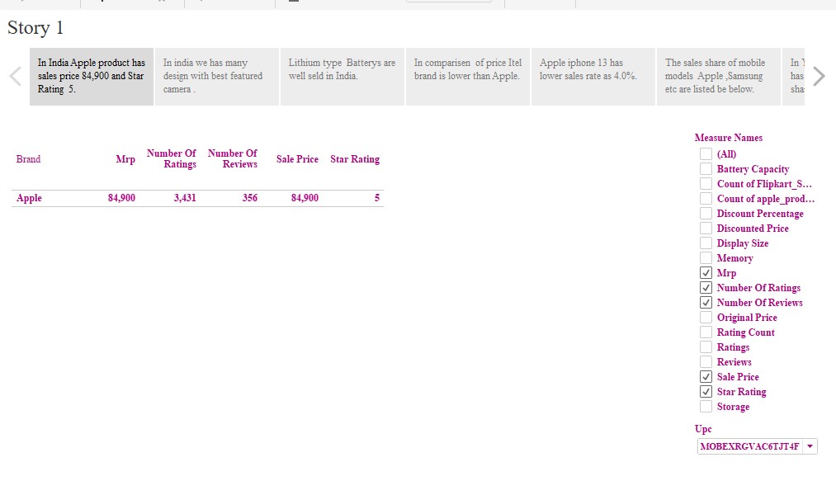

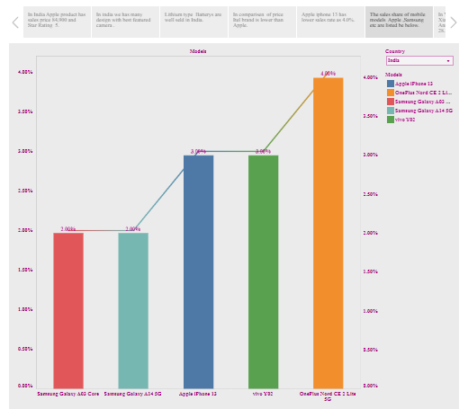

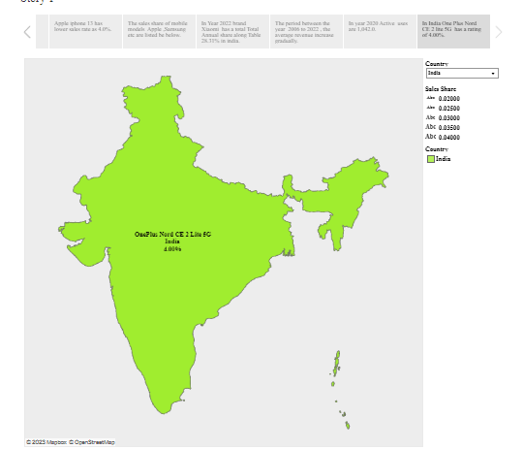

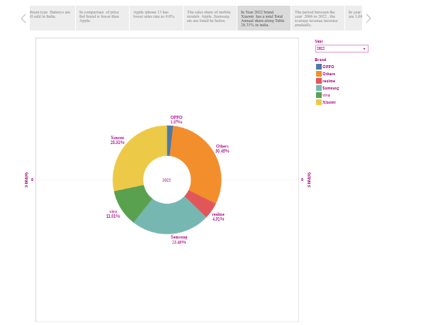

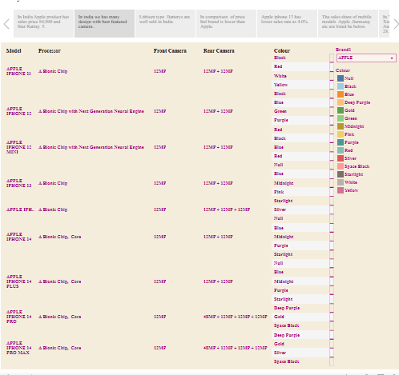

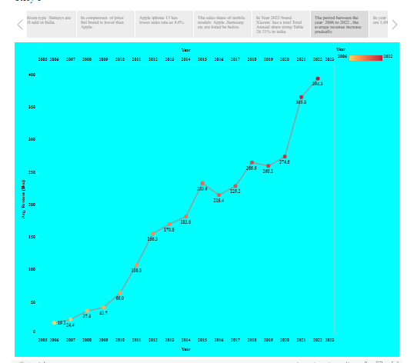

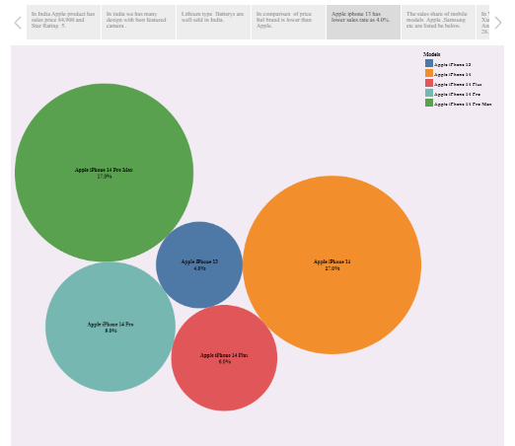

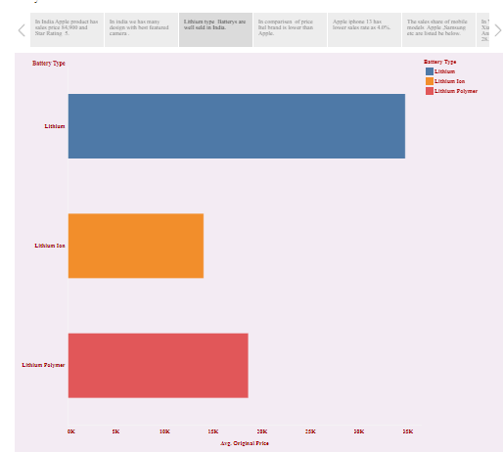

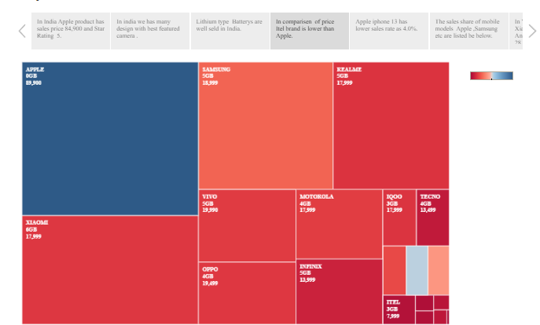

1. ADVANTAGES & DISADVANTAGES

ADVANTAGES

1.Technological advancement

2.Economic growth

3.Digital inclusion

4.Education and skill development

5.E-commerce boom

6.Health and fitness

DISADVANTAGES

1.Cost

2.E-waste

3.Dependency

4.Privacy concern

5.Monopoly

6.Socio-economic inequality

7.Local competition

1. APPLICATIONS

1.Market analysis

2.Government policy

3.Education and skill development

4.App development

5.Consumer awareness

6.Sustainable practice

7.Social initatives

8.Data privacy and security

1. CONCLUSION

“IRevolution “ is a data-driven exploration of the impact of Apple iPhones in India .The exploration delves into various aspects such as economic impact,market penetration ,user behavior ,and socio-cultural implications . The conclusion highlights the transformative effect iPhones have had on the Indian tech landscape ,influencing consumer preferences,contributing to the digital economy and fostering technological innovation.